**DEMO2002 W6 Tutorial**

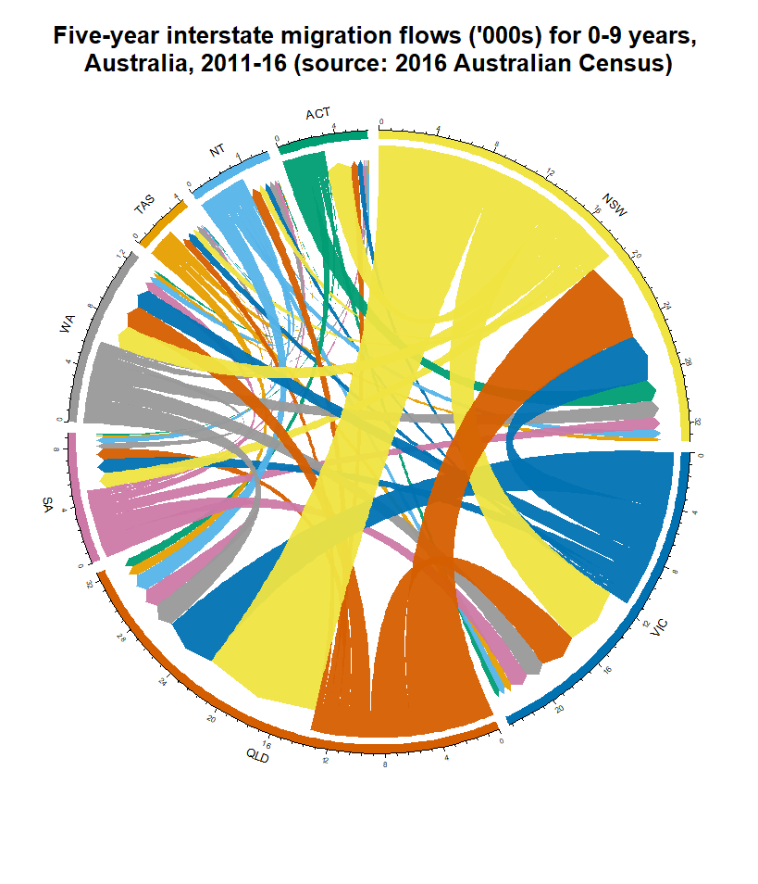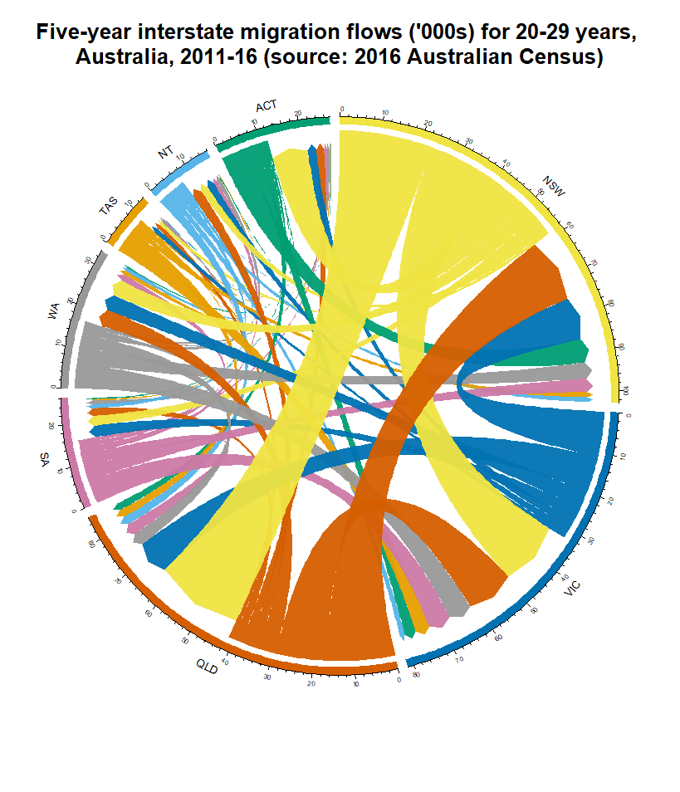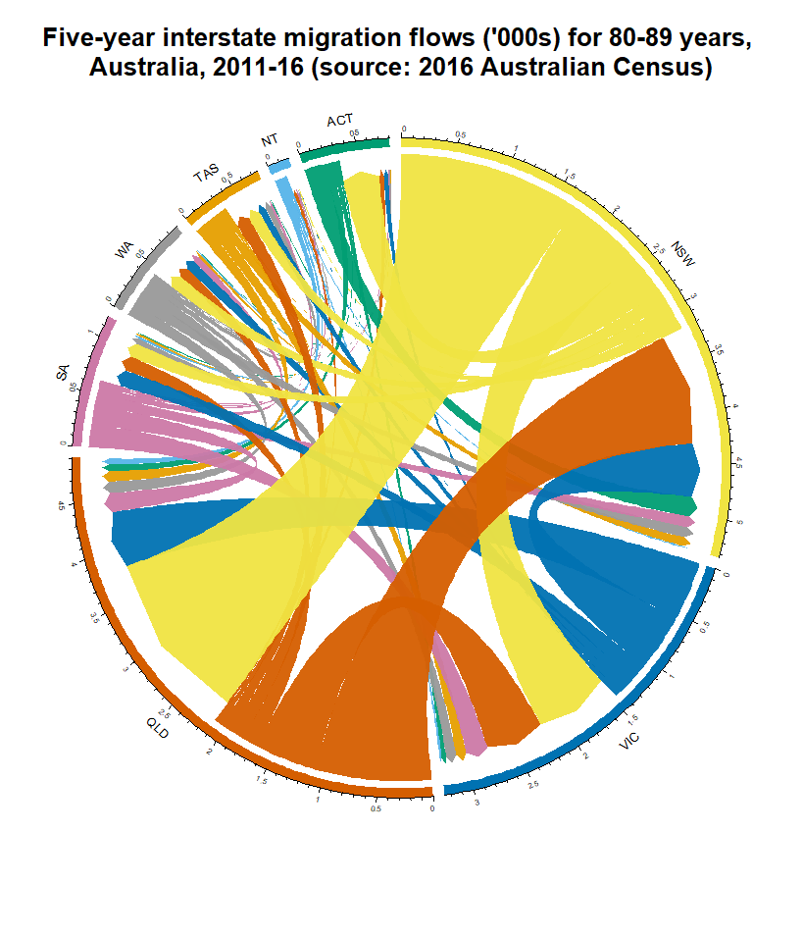

In the previous plots, we have displayed the internal migration flows in Australia (2011-16) for three age demographics: 0-9 years, 20-29 years, and 80-89 years. This lets us examine the migration behaviour for infant and very young children, young adults, and elders. As we might expect from learning about the age-specific migration patterns, young adults aged 20-29 in Australia had the greatest volume of internal migration during the five-year period between the three demographics. In the 20-29 years plot, in-migrants make up a marginally larger portion of the flows for the ACT and VIC relative to the 0-9 and 80-89 graphs. This might be explained by young individuals moving interstate to attend prominent universities, such as VIC’s UniMelb or Monash University, and ACT’s ANU. While NSW also possesses prestigious educational institutions, this region is vast and contains abundant employment opportunities. Considering the large age interval in consideration (10 years), employment-motivated migration may drown out education-related movement in the 20-29 years plot.

Unfortunately, the similar appearances of the chord diagrams are deceptive in making scale comparisons unless one closely examines the tick marks. In fact, the migration flows for 80-89 are miniscule compared to 0-9 or 20-29. For example, across all states, there is a gross migration of 8,666 people for those aged 80-89, compared to 63,682 (for 0-9 years) and 193,335 (for 20-29 years).

Despite the importance of regional-level migration in facilitating skills and labour exchange, studies have highlighted its deterioration in recent years. Kalemba *et al.* (2022) observed the decline across all migration incentives; they undermined the explanation that technological solutions substituted migration and suggested that behavioural changes like place attachment may have influenced lower social mobility.

**References**

Kalemba, S.V. *et al.* (2022) ‘Has the decline in the intensity of internal migration been accompanied by changes in reasons for migration?’, *Journal of Population Research*, 39(3), pp. 279–313. Available at: https://doi.org/10.1007/s12546-022-09285-5.